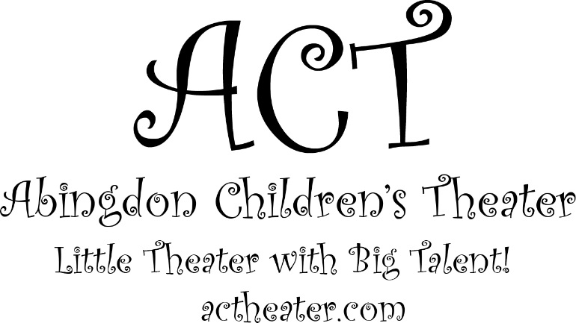 |  |  | Abingdon Children’s Theater  Presents  Music By  Alan Menken  Lyrics by  Howard Ashman and Glenn Slater  Book by  Doug Wright  October 7th 1:00 & 4:30 at  Patterson Mill High School Auditorium  85 Patterson Mill Rd.  Bel Air MD, 21015  For Questions go to ACTheater.com  Sponsored by the Emmorton Recreation Council

Director Marilda Miller  Assistant Director Ali Leary  Choreography Nick Vach  Musical Director Adrian Gonzalez, Max Stover  Costume Design Renee Hartley, Stella Dipeso, Marilda Miller  Spot Lights Sarah Lambeth, Lizzy Gutridge  Stage Manager Dominique Lewis  Crew Members Christopher Osborn, Susan Osborn, Xu Smith, Kol Miller  Sound Melody Lewis  Make up Sarah Lambeth, Dominique Lewis, Xu Smith  Lighting Design/Web Design/Media Design/Carpentry/ Transport/Equipment Support/IT Support/ Technical Monkey Michael Miller  Thank you to all the parents for their help and support.  Thank you to ERC Council and Management for their help and sponsorship. Without your support The Little Mermaid could not have happened. |  |  | We are fundraising!  Visit our campaign at:  https://actheater.causevox.com/  Donations will help pay for the microphones and lights used in our show!

Visit us on Facebook!  Abingdon children’s Theater |  |  | Sea Chorus Charlie Smith, Ashley Kirk, Alden Stewart, Courtney Conwell, Natalie Ruano, Alice Hartley, Claire Hartley, Bray Moiles, Lucas Mcdougall, Melissa Provenza, Devin Vichot, Isabella Gerald, Elizabeth Hammond, Avery Gerald, Hannah Kries, Kyleigh Loyola, Moriah Lewis, Carley Lewis  Pilot Brendan Stewart  Sailors Lucas Mcdougall, Bray Moiles, Courtney Conwell, Isaac Miller, Carley Lewis, Raegan Decker, Sophia George,Brody Riolo, Andy Serio  Prince Eric Max Stover  Grimsby Nick Vach  Seahorse Charlie Smith  King Triton Adrian Gonzalez  Sebastian Molly McVicker  Mersisters:  Aquata Melissa Provenza  Andrina Moriah Lewis  Arista Elizabeth Hammond  Atina Kyleigh Loyola  Adella Devin Vichot  Allana Isabella Gerald  Ariel Ali Leary  Flounder Raegan Decker, Brody Riolo  Scuttle Allison Berger

Gulls Hannah Kries, Emma Provenza, Julia DeLacey  Ursula Lindsay Serio  Flotsam & Jetsam Hope Boyle, Jaime Gaeng  Carlotta Hannah Kries  Chef Louis Sophia Jorge, Andy Serio  Chefs Brendan Stewart, Isaac Miller, Lucas Mcdougall, Natalie Ruano, Alice Hartley, Carley Lewis  Lagoon Animals Charlie Smith, Alice Hartley, Claire Hartley, Natalie Ruano, Alden Stewart, Brody Riola, Raegan Decker, Avery Gerald, Lucas Mcdougall , Ashley Kirk, Moriah Lewis, Carley Lewis, Melisa Provenza, Devin Vichot, Elizabeth Hammond, Isabella Gerald  Princesses Moriah Lewis, Kyleigh Loyola, Elizabeth Hammond, Melissa Provenza, Devin Vichot, Isabella Gerald |  |  | Fall/Winter 2017-2018 Session!  Registration for Fall/Winter 2017-2018 has started!  Age Group 6-7 meets on Mondays  Starts on October 16th  Time: 6:00-7:15pm  Place: Emmorton Recreation Center  Age Group 8-9 meets on Wednesdays  Starts on October 18th  Time: 5:30-7:30pm  Place: Emmorton Recreation Center  Age Group 10-15 meets on Fridays and Saturdays  Starts on October 20th  Friday Rehersal:  Time: 5:30-8:00pm  Place: Patterson Mill High School  Saturday Rehersal  Time: 10:00am-12:00pm  Place: Emmorton Recreation Center  Class will include a break so please bring a healthy snack!  Note: Registrations will end as soon as all spots are filled!

