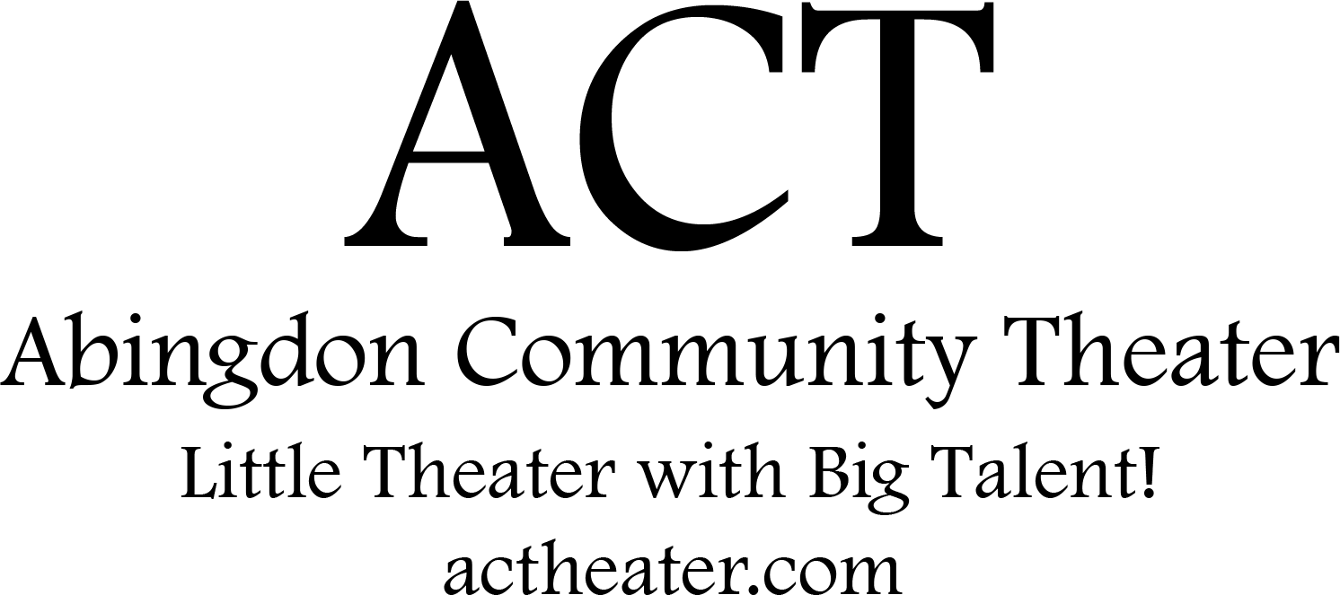

Disney’s Alice in Wonderland JR. is presented through special arrangement with and all authorized materials are supplied by Music Theatre International, New York, NY
(212) 541-4684 mtishows.com
Abingdon Community Theater’s
production of
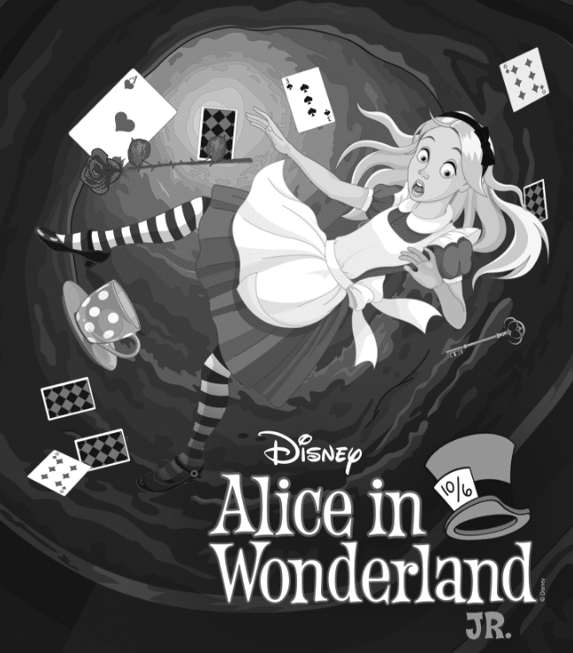

Music and Lyrics by
Sammy Fain & Bob Hilliard,
Oliver Wallace & Cy Coban,
Allie Wrubel & Ray Gilbert,
Mack David, Al Hoffman & Jerry Livingston

Music Adapted and Arranged and

Additional Music and Lyrics by
Bryan Louiselle

Book and Additional Lyrics by
David Simpatico

Based on the 1951 Disney film Alice in Wonderland
and the novels The Adventures of Alice in Wonderland and Through the Looking-Glass by Lewis Carroll

SCENES & MUSICAL NUMBERS

PROLOGUE: DAYDREAMING IN THE PARK
Dodgsonland Park Kids, Alice, Mathilda
I’m Late White Rabbit, Wonderland Characters

SCENE 1: DOWN THE RABBIT HOLE
Very Good Advice Alice, Wonderland Characters

SCENE 2: KNOCK KNOCK KNOCK

SCENE 3: SWIMMING INTO WONDERLAND
Ocean of Tears Dodo Bird, Sea Creatures

SCENE 4: JOLLY CAUCUS RACE
The Caucus Race Dodo Bird, Small Alice, Sea Creatures
I’m Late (Reprise) White Rabbit, Wonderland Characters
How D’ye Do and Shake Hands Tweedle Dum, Tweedle Dee, Alice
How D’ye Do and Shake Hands (Reprise) Tweedle Dum, Tweedle Dee

SCENE 5: MONSTER IN MY HOUSE

SCENE 6: BRAVING THE GARDEN
The Golden Afternoon Rose, Lily, Petunia, Daisy, Violet
Zip-A-Dee-Doo-Dah Caterpillar, Small Alice, Wonderland Characters

SCENE 7: MAD TEA PARTY
The Unbirthday Song March Hare, Mad Hatter, Alice, Party Guests
I’m Late (Reprise 2) White Rabbit, Party Guests

SCENE 8: SEEING RED
Painting the Roses Red Royal Cards, Alice
Painting the Roses Red (Reprise) Queen of Hearts, Royal Cards
Simon Says Queen of Hearts, Alice

SCENE 9: ALICE ON TRIAL
The Unbirthday Song (Reprise) Mad Hatter, Queen of Hearts,
King of Hearts, Wonderland Characters
Whooo Are Youuu? Alices, Wonderland Characters

EPILOGUE: WAKING IN THE PARK
Finale Company
Zip-A-Dee-Doo-Dah (Bows) Company

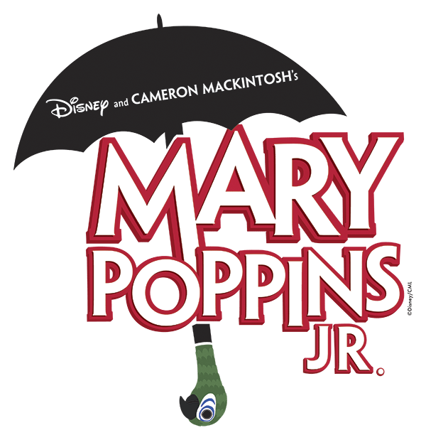

Registrations for our next show, Mary Poppins Jr, are now open! For details please visit actheater.com

For questions please email us at:
act@actheater.com

We are fundraising!
Visit our campaign at:
https://actheater.causevox.com/
Donations will help pay for the microphones and lights used in our show!

PRODUCTION TEAM

Director Marilda Miller
Producer Michael Miller
Music Director Marianne Pastelak
Choreographer Lauren Chapmen, Marilda Miller
Set Designer Marilda Miller
Set Crew Michael Miller, Emilio Jorge, Todd Ellefson, Natalie Forest, Marilda Miller, Ray Ruiz
Lighting Designer Brad Paulsen
Stage Crew Natalie, Vanbreukelen, Natalie Forrest, Sherry Ellefson, Corinne Slaysman, Carisa Dowling
Props Master Marilda Miller, Jennifer McNally
Costumes Renee Hartley, Jennifer McNally, Marilda Miller
Sound Designer Josh Oltarzewski, Julianna Brooks, Mark Novak, Nayla Kuhn
Make Up Marilda Miller, Lily Ellefson, Julianna Brooks,Hayley Neal, Allison Berger, Sherri Ellefson, Miss Pruett, Candace Carta

Thank you to all the parents for their help and support.
Thank you to ERC Council and Management for their help and sponsorship. Without your support this production could not have happened.

CAST

(in order of appearance)

Mathilda Ciena Keams
Alice Grace Myers and Hayley Neal
Cheshire Cat Sarah De Nichilo, Lexie Merrifield, Abigail Madsen, Molly Jurch, Meara Waida, Ashlynn Uphoff
White Rabbit Alison Berger and Emily Sinclair
Mad Hatter Kol Miller
Queen of Hearts Lily Ellefson and Lindsay Serio
Dodo Bird Kyleigh Loyola and Jonah Wada
Rose Abrianna Guzman
Doorknob Felicity Forest
Tall Alice Madeline Tunney and Sophia Engel
Small Alice Kira Pappas and Andrea Serio
Tweedle Dum Raegan Decker
Tweedle Dee Olivia Melvern
Lily Emily Engel
Petunia Melody Morrison
Daisy Gabrielle Kunz
Violet Ella Neuberger
Caterpillar Logan Taylor and Henry Weber
March Hare Grace Jurgs and Caiden Donovan
Flowers of the Golden Afternoon Annabelle Hunter, Alice Hartley, Leighanna Robin, Lily Colon, Sophia Jorge
King of Hearts Fin Marini

ENSEMBLE

Park Kids, Wonderland Characters, Sea Creatures,
Party Guests, Royal Cards
Alaina Bell, Harmony Morrison, Lili Colon, Alex Colon, Sophia Jorge, Lilah Fodel, Emma Himes, Brayden Tompkins Dahlia Gamboa, Maria Thomas, Michael Thomas, Lucas Maier, Ellie Roemer, Theo Stephen, Alaina Scarff, Charlie Lyden, Tatum Hughes, Ada Griffin, Andrew Birch, Adrianna Breindel, Hayden Pruett, Leighanna Robin, Ryan Aquilina, Gabrielle Jennings, Rose Wagner, Taylor Brookman, Peyton Walters, Lily Ruiz, Ciara Reed, Margaret Gotfredson, Katherine Gotfredson, Olivia Scarff, Gemma Regan, Courtney Conwell, Macee Skelton, Aidan Parker, Sophia Lowery, Ivy Croddick, Sophia Hurley, Ilana Shea, Emily Shrader, William Shek, Keely Glowacki, Jeremiah Diego, Claire Hartley Makayla Goodie, Alice Harley, and Isaac Miller

A big thank you to the fundraising parents for their continuing support and donations: Krista Decker, Kristine Murphy, Stephanie Pena, Kathleen Engel, and Christina Pappas

