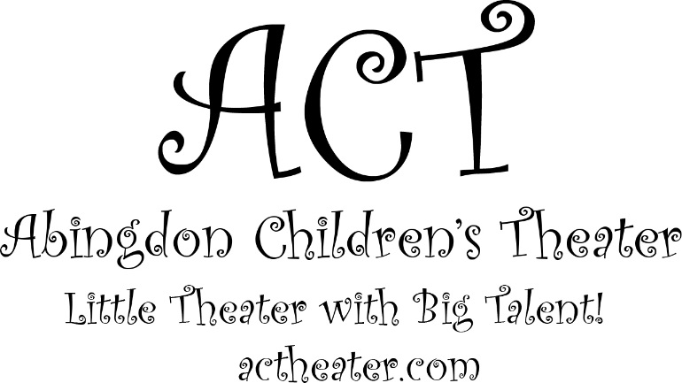 |  |  | 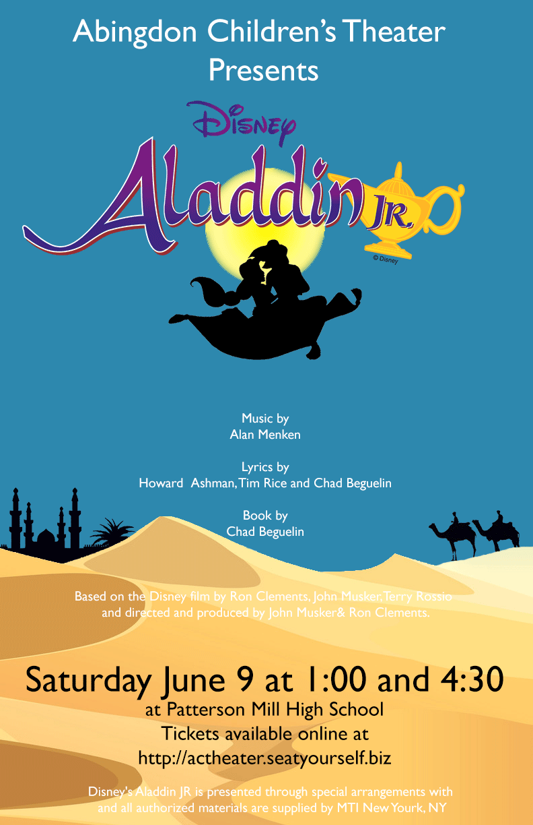

Director Marilda Miller  Assistant Director Domenique Lewis  Choreography Domenique Lewis  Musical Director Domenique Lewis, Marilda Miller, Sarah Lambeth, Nick Vach  Costume Design Renee Hartley, Marilda Miller  Stage Manager Marilda Miller  Assistant Stage Manager Lilly Ellefson  Backstage Stage Manager Sarah DeNichilo, Ciena Keams  Makeup Marilda Miller, Lilly Ellefson, Kathleen Engel, Domenique Lewis, Melodi Lewis, Tory Allman  Scenography Marilda Miller  Crew Members Emilio George, Ellen King, Natalie Vanbreukelen, Xu Smith, Jennifer Lyttle, Kathleen Engel, Josh Birch, Alex Birch  Sound Domenique Lewis, Katie Romano  Lighting Design/Web Design/  Media Design/Carpentry/  Transport/Equipment Support/  IT Support/Technical Monkey Michael Miller  Thank you to all the parents for their help and support.  Thank you to ERC Council and Management for their help and sponsorship. Without your support Aladdin could not have happened. |  |  | We are fundraising!  Visit our campaign at:  https://actheater.causevox.com/  Donations will help pay for the microphones and lights used in our show!  Auditions for the Beauty and the Beast Summer Musical are on  June 20th June 27th  at 5:30- 8:00pm  at the Emmorton Recreation Center.  This performance is for Middle and High School age groups.  To register for an audition or for details please email us at:  act@actheater.com

Thank you to Rick Stutzer for your donation in the loving  memory of your musician brother David Stutzer.  "May he always sing in heaven while we sing on earth."  Thank you to Sweet Treats By Denise, for her donation to ACT. Check out her amazing art work of Homemade Cakes, Cookies, Cupcakes, and Treats for every occasion on Face Book. Or contact Denise at deniseftag@gmail.com.  Thank you for your donation Crystal Griffin!  To order crocheted or custom handmade gifts contact  Crystal at adasmama.cg@gmail.com or go to  https://www.etsy.com/shop/crystalshomemadeshop.  A big thank you to the fundraising parents for their continuing support and donations: Krista Decker, Melissa Boyle, Kelly DeNichilo, Alicia Gerald, Stephanie Pena, Kristine Murphy, and Susan Kunz. |  |  | Aladdin Kol Miller  Genie Sophia Jorge  Kassim Lindsay Serio  Omar Lea Echegaray  Babkak Mark Sans  Jasmine Moriah Lewis  Jafar Joseph Fields  Iago Allison Berger  Sultan Olivia Melvern  Razoul Jaden Long  Guard 1 Brooklyn Nixon  Guard 2 Titus Lyttle  Carper Grace Jurgs  Apple Vendors Raegan Decker, Hope Boyle  Fortune Teller Isabella Gerald, Melody Morrison  Attendant Gabrielle Kunz, Melody Morrison  Prince Abdullah Sam Davis  Isir Hayley Neal  Manal Sarah DeNichilo  Rajah Kyleigh Loyola  Spooky Voice Lily Ellefson  Cave Of Wonders Sam Davis

Shop Owners  Gabrielle Kunz, Autumn Smoother, Zoe Pappas, Elizabeth Hammond  Other Guards  Joshua Kunz, Evan Jalbert, Ryan Aquilina, Alex Baxley, William Shek  Beggars  Jeremiah Diegue, Dahlia Gamboa, Theodor Stephen,  Luke Bednarek, Charley Smith, Arabelle Engle-Shanholtz, Ella Johnson, Isaac Cook, Andrew Birch, Isaac Miller  Ensemble  Includes Agrabahn’s and Prince Ali's Entourage  Emily Shrader, Taylor Brookman, Kaia Lurz, Gabrielle Jennings,  Kira Pappas, Cortney Conwell, Elizabeth Hammond, Gemma Regan, Riley Brink, Lillian Schopf, Harmony Morrison, Macee Skelton,  Ella Neuberger, Kori Eakin, Keira Littrell, Andy Serio, Gabrielle Kunz, Emily Engel, Ciena Kearns, Zoe Pappas, Melody Morrison,  Autumn Smothers, Ciara Reid, Marleigh Skelton, Ryann Kight,  Emily Bowling, Kaitlyn Grimm, Lily Dunning, Maddie Koors,  Emilio Jorge, Dulles Diegue |  |  | 