Autographs:

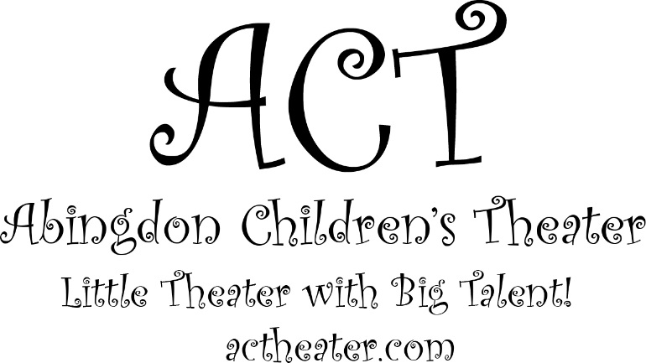

Director Marilda Miller  Musical Director Marianne Pastelak  Set Design Tod Ellefson  Costume Design Renee Hartley, Marilda Miller  Stage Manager Marilda Miller  Assistant Stage Manager Lilly Ellefson  Makeup Marilda Miller, Lilly Ellefson, Tory Allman  Scenography Marilda Miller  Crew Members Emilio George, Ellen King, Natalie Vanbreukelen, Josh Birch, Alex Birch, Tod Ellefson  Sound Tory Allman, Josh Oltarzewski, Tim Kaczkowski  Lighting Design/Web Design/  Media Design/Carpentry/  Transport/Equipment Support/  IT Support/Technical Monkey Michael Miller  Thank you to all the parents for their help and  support. Thank you to ERC Council and Management  for their help and sponsorship. Without your support  this production could not have happened. |  |  | We are fundraising!  Visit our campaign at:  https://actheater.causevox.com/  Donations will help pay for the microphones and lights used in our show!

A big thank you to the fundraising parents for their  continuing support and donations.  Abingdon Children's Theater  Note from the Director:  Thank you everybody for all your kind words, emails, and your constant support. Without you there is no spotlight to shine on our children. – Marilda Miller |  |  | Cast  Narrators Meara Waida, Lea Echegaray, Abrianna Guzman  Prince / Beast Mark Novak III  Old Women/ Enchantress Tory Allman  Belle Lily Ellefson  Gaston Joey Fields  Lefou Evan Snodgrass  Silly Girls Melissa Provenza, Olivia Melvern, Kyleigh Loyola, Raegan Decker, Sophia Jorge  Maurice Kol Miller  Cogsworth Raegan Decker, Sophia Jorge  Lumiere Omar Simpson, Allison Berger  Babette Noelle Ferg  Mrs. Potts Lindsay Serio  Chip Kori Eakin, Brayden Thompkins  Madame de la Grande Bouche Julianna Brooks  Monsieur D'Arque Finn Marini, Caiden Donovan  Baker Hope Boyle  Bookseller Jaime Gaeng  Marie Lea Echegaray  Servant Mark Sans

Villagers  Angela Young, Courtney Conwell, Emma Provenza, Linnea Hansen, Andi Serio, Leighanna Robin, Liliana Colon, Anthony Alexander Colon, Isaac Miller, Noelle Ferg, Julianna Brooks, Madeleine Tabor, Allison Berger, Omar Simpson, Meara Waida, Abriana Guzman, Mark Sans.  Wolves  Angela Yeung, Andrea Serio, Hope Boyle, Courtney Conwell, Emma Provenza, Leighanna Robin, Liliana Colon, Anthony Alexander Colon, Chloe Bang  Utensils  Angela Young, Courtney Conwell, Hope Boyle, Emma Provenza, Andi Serio, Linnea Hansen, Chloe Bang, Leighanna Robin, Liliana Colon, Anthony Alexander Colon, Isaac Miller, Jaime Gaeng, Finn Marini, Caiden Donovan, Allison Berger, Olivia Melvern. Meara Waida, Melissa Provenza, Abriana Guzman, Kyleigh Loyola, Mark Sans  Musical Numbers  Belle Belle, Gaston, Villagers  Belle (Reprise) Belle, Silly Girls  Home Belle  Home (Tag) Mrs. Potts, Madame De La Grand Bouche  Gaston Gaston, Lefou, Silly Girls, Villagers  Gaston (Reprise) Gaston, Lefou  Be Our Guest Lumiere, Chip, Mrs.Potts,Servants  Something There Beast,Belle, Servants  Human Again Servants  Beauty and the Beast Mrs. Potts  The Mob Song Gaston, Villagers  Home (Reprise) Belle  Finale Company |  |  | 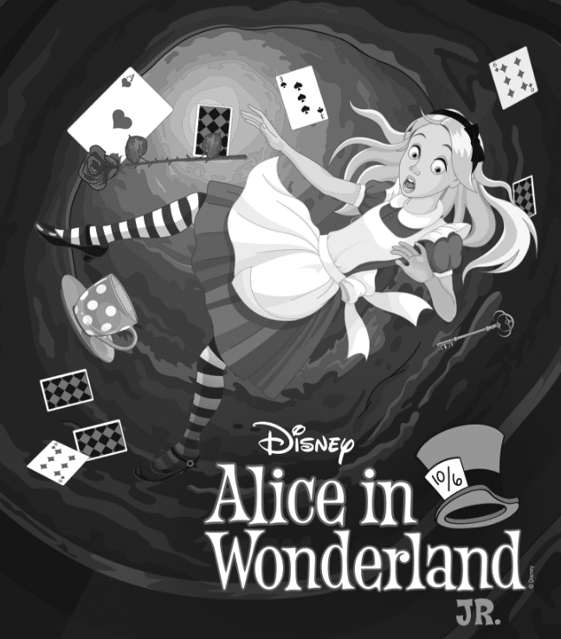  Registrations for  Alice in Wonderland Jr  are now open!  For details please visit:  actheater.com

