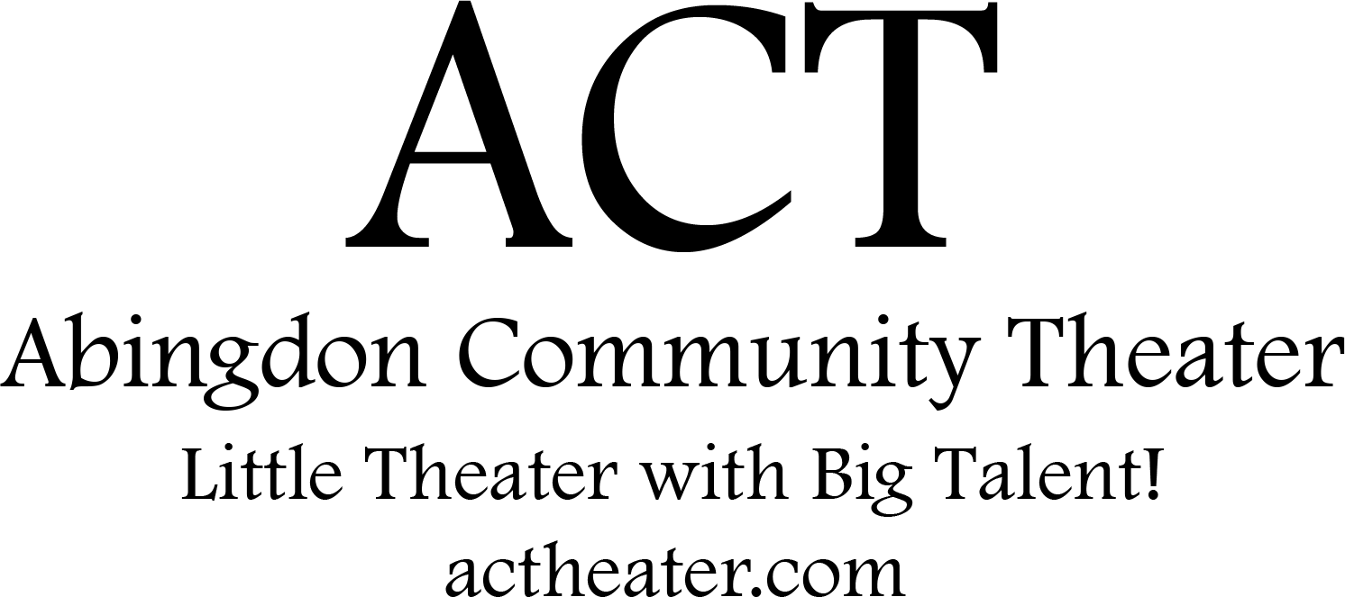

Disney’s Frozen JR. is presented through special arrangement with and all authorized materials are supplied by Music Theatre International, New York, NY 212-541-4684 mtishows.com

Abingdon Community Theater’s
production of

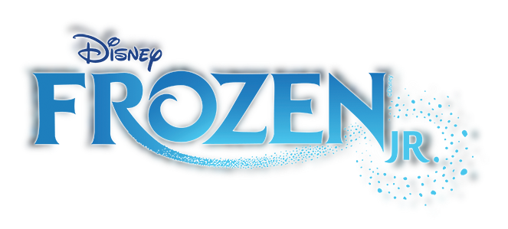

Music & Lyrics by
Kristen Anderson-Lopez & Robert Lopez

Book by
Jennifer Lee

Based on the Disney film written by
Jennifer Lee and directed by Chris Buck and Jennifer Lee

SCENES & MUSICAL NUMBERS

SCENE 1: SUMMER FESTIVAL

Let the Sun Shine On Young Anna, Young Elsa, King Agnarr,

Queen Iduna, Townspeople

SCENE 2: CASTLE INTERIOR

A Little Bit of You Young Elsa, Young Anna, Snow Chorus

First Joik Queen Iduna, Pabbie, Bulda, Hidden Folk

SCENE 3: CASTLE INTERIOR, A FEW MONTHS LATER

Do You Want to Build a Snowman? Young Anna, Middle Anna,

Middle Elsa, Townspeople

SCENE 4: CASTLE INTERIOR, THREE YEARS LATER

For the First Time in Forever Anna, Elsa, Castle Staff, Townspeople

SCENE 5: CASTLE INTERIOR, CORONATION CEREMONY

Dangerous to Dream Elsa, Anna, Townspeople

SCENE 6: CASTLE INTERIOR, CORONATION BALL

Love Is an Open Door Anna, Hans, Townspeople

SCENE 7: SNOWY MOUNTAINSIDE

Reindeer(s) Are Better Than People Kristoff, Sven

You're Hired Olaf

In Summer Olaf, Sven, Summer Chorus

SCENE 8: WANDERING OAKEN'S

Hygge Oaken, Oaken's Family, Anna, Olaf, Sven, Kristoff

SCENE 9: NORTH MOUNTAIN

Let It Go Elsa, Snow Chorus

SCENE 10: MOUNTAIN PATH

SCENE 11: ELSA'S PALACE

For the First Time in Forever (Reprise) Anna, Elsa, Snow Chorus

Mountain Fall Snow Chorus

SCENE 12: FOOT OF THE MOUNTAIN

Kristoff's Joik Kristoff, Hidden Folk

Fixer Upper Pabbie, Bulda, Hidden Folk, Olaf

SCENE 13: CASTLE INTERIOR

SCENE 14: CASTLE EXTERIOR

Colder by the Minute Elsa, Snow Chorus, Townspeople
Finale Company
Registrations open soon!

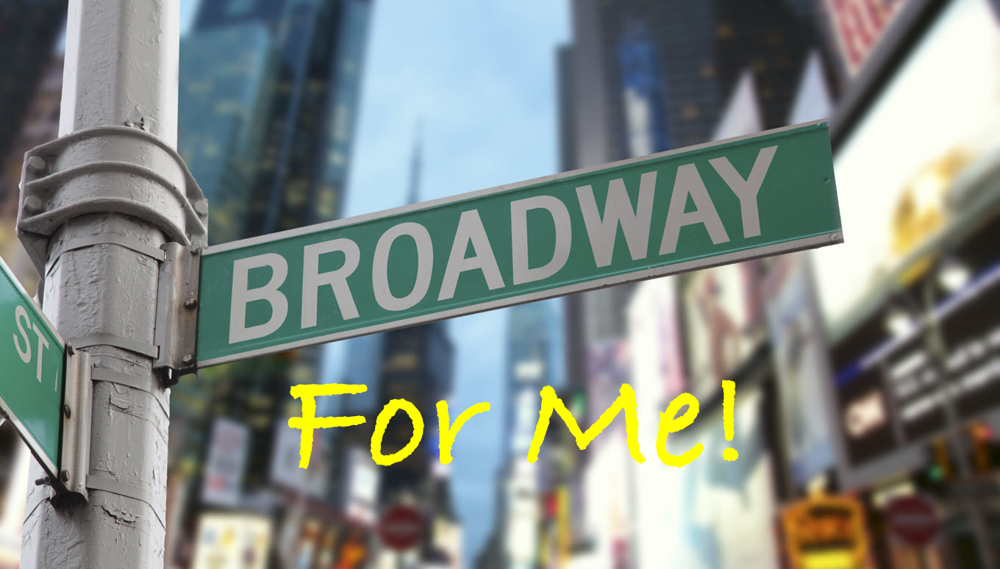
Broadway For Me!
Our spring session will create the most fantastic
scenes based on Broadway musicals.
Registrations open on Feb 10th.
Age group 6-8 meet on Monday’s.
Age group 9-10 meets on Wednesday’s.

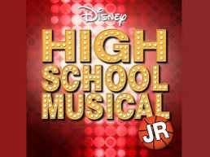
High School Musical Jr.
Registrations start on February 10th.
To audition for main characters please email us
at act@actheater.com for details.
Auditions are on February 15th & 22nd at ERC.

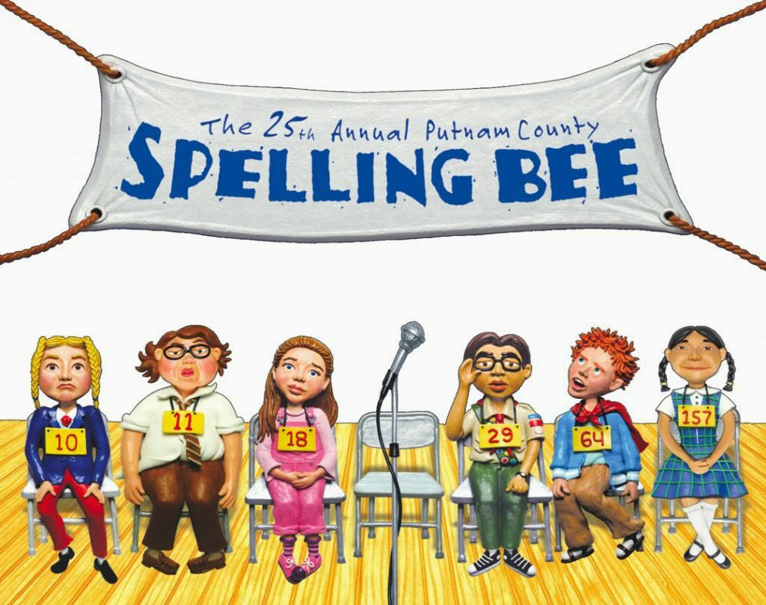
The 25th Annual Putnam County Spelling Bee
Now in production!

Thank You!

Thank you to Wegman’s for your continued sponsorship!

Thank you to the Conwell Family for your generous donation!

Thank you to all the parents for their help and support.

Thank you to ERC Council and Management for their help and sponsorship. Without your support this production could not have happened.

A big thank you to the fundraising parents for their continuing support and donations!

For questions please email us at:
act@actheater.com

PRODUCTION TEAM

Director Marilda Miller
Producer Michael Miller
Music Director Elizabeth Devito
Costume Designer Renee Hartley, Betty Rogers, Marilda Miller
Lighting Designer Brad Paulsen
Stage Crew Michael English, Lily Ellefson, Josh Rozmiarek,
Emily Sinclair, Logan Folmer, Ethan Folmer,
Genevieve Sudbrink, Cailin Peluso,
Kol Miller, Aaron Brown, Peyton Geraci
Props Master Lindsay Serio, Hayley Neal, Allison Berger,
Henry Weber, Drew Opdyke, Marilda Miller
Sound Designer Josh Oltarzewski

We are fundraising!
Visit our campaign at:
https://actheater.causevox.com/
Donations will help pay for the microphones and lights used in our show!

CAST

(in order of appearance)

Young Anna Dahlia Gamboa, Kira Pappas
Young Elsa Ada Griffin, Brielle Patton
King Agnarr Henry Hoffmann
Queen Iduna Emily Morey, Haley Guicheteau
Pabbie Melody Morrison, Grace Jurgs
Bulda Madeline Mobley, Abrianna Guzman
Middle Anna Hannah Huber, Courtney Conwell
Middle Elsa Ella Neuberger, Ciara Reid
Bishop Caiden Donovan
House Keeper Andrea Serio
Butler Ivy Croddick
Handmaid Alaina Bell
Cook Harmony Morrison
Anna Hayley Neal, Allison Berger
Elsa Lindsay Serio
Kristoff Jonah Wade, Henry Weber
Sven Cooper Hoagland, Jeremiah Diegue
Hans Marc Sans, Drew Opdyke
Steward Myra Laubach
Duke of Weselton Titus Lyttle
Olaf Raegan Decker, Sophia Jorg
Oaken Alyssa Robinson

ENSEMBLE
Townspeople and Castle Staff
Meara Waida, Addison Becker, Caiden Donovan, Myra Laubach, Alaina Bell, Charisma Huber, Haley Guicheteau, Ivy Croddick, Martha Lent, Emily Morey, Charis Huber, Raegan Decker, Ella Neuberger, Andrea Serio, Melody Morris, Harmony Morris, Sophia George, Courtney Conwell, Henry Hoffman
Snow Chorus
Felicity Forest, Emily Morey, Charis Huber, Raegan Decker, Hannah Huber, Grace Jurgs, Hayley Neal, Allison Berger, Caiden Donovan, Meara Waida, Ivy Croddick, Martha Lent, Madeline Mobley, Emery Walker, Christian Diegue, Andrew Birch, Camila Sarmiento, Cameron Devino, Ellie Roemer, Jozion Cruz, Geogia Reid, Leina Kehl, Olivia Norman, Caroline Feldt, Lily Simpson, Livvy Krout
Hidden Folks
Noah Marshall, Lily Ruiz, Camryn Ramsel, Keely Glowacki, Brielle Patton, Theo Stephen, Harmony Morrison, Kirsten Martin, Courtney Conwell, Maxton Folmer, Brynn Sauer, Gemma Regan, Lucas Maier, Caelyn Liles, Kennedy Finlay, Emily Nickel, London Blankenship, Sofia Robertson
Summer Chorus
Emery Walker, Christian Diegue, Andrew Birch Camila Sarmiento, Cameron Devino, Ellie Roemer, Jozion Cruz, Geogia Reid, Leina Kehl, Olivia Norman, Caroline Feldt, Lily Simpson, Livvy Krout
Oaken’s Family
Alyssa Robinson, Noah Marshall, Lily Ruiz, Camryn Ramsel, Keely Glowacki, Brielle Patton, Theo Stephen, Harmony Morrison, Kirsten Martin, Courtney Conwell, Maxton Folmer, Brynn Sauer, Gemma Regan, Lucas Maier, Caelyn Liles, Kennedy Finlay, Emily Nickel, London Blankenship, Sofia Robertson, Felicity Forest, Ciara Reid, Courtney Conwell, Kira Pappas

