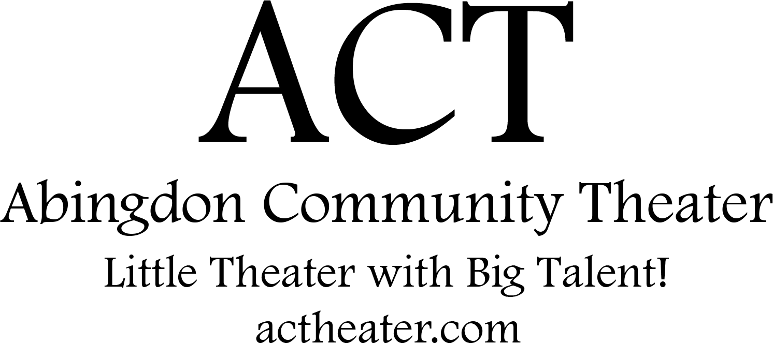

Disney and Cameron Mackintosh’s Mary Poppins JR. is presented
through special arrangement with
and all authorized materials are supplied by
Music Theatre International, New York, NY
Abingdon Community Theater’s
production of

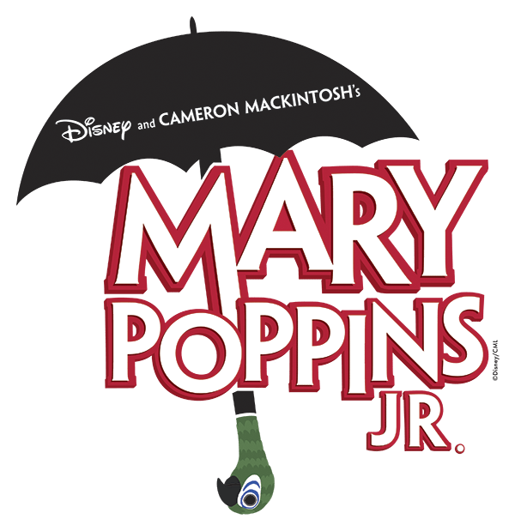

Original Music and Lyrics by
Richard M. Sherman and Robert B. Sherman

Book by
Julian Fellowes

New Songs and Additional Music and Lyrics by
George Stiles and Anthony Drewe

PRODUCTION TEAM

Director Marilda Miller
Producer Michael Miller
Music Director Marianne Pastelak
Choreographer Bryanna Ostendorf, Marilda Miller
Set Designer Marilda Miller, Tod Ellefson,
Dave Ferg, Patti Hunter
Costumes Renee Hartley, Marilda Miller, Betty Rogers
Lighting Brad Paulsen, Michael English, Aaron Brown
Props Marilda Miller, Natalie Forest, Sherri Ellefson
Sound Josh Oltarzewski, Julianna Brooks, Taylor Braun
Makeup Aaron Brown, Kacey Love, Taylor Braun
Stage manager Sherri Ellefson, Natalie Forest

SPECIAL THANKS

A big thank you to all the amazing parents backstage, in the lobby, and in the audience for their continued help and support on this journey.

Thank you for your donations!
Fritz Farm & Nursery, Wegmans, Gene’s Evergreens

Thank you to ERC Council and Management for their help and sponsorship. Without their support this production could not have happened.

Autographs:

Autographs:

CAST

(in order of appearance)

Bert Kol Miller
George Banks Joshua Rozmiarek
Winifred Banks Hayley Neal, Noelle Ferg
Jane Banks Allison Berger, Raegan Decker
Michael Banks Isaac Miller, Jonah Wade
Katie Nanna Ciena Kearns, Abrianna Guzman
Mrs. Brill Melody Morrison, Grace Jurgs
Robertson Aya Kyleigh Loyola
Mary Poppins Lily Ellefson, Emily Sinclair
Neleus Caiden Donovan, Gavin Reiley
Bird Women Sarah DeNichilo, Abigail Madsen
Miss Smith Elizabeth Hammond, Izzy Gerald
Chair Women Hannah Huber, Meara Waida
Von Hossler Natalie Forest
John Northbrook Henry Weber
Mrs. Corry Sophia Engel
Miss Andrew Lindsay Serio
Policeman Titus Little
Messenger Gabrielle Kunz

ENSEMBLE

Park Strollers, Status, Kite Flyers
Cooper Hoagland, Deanna Sappington, Kaya Lurz, Ryan Aquilina, Lilah Fodel, Courtney Conwell, Elizabeth Hammond, Lorelei Hunter, Emily Shrader, Eleanor Marschhauser, Alice Hartley, Claire Hartley, Katie Gotfredson, Alex Baxley, Ava Dey, Kira Pappas, Sophia Lowery, Brooklyn Szewczyk, Harmony Morrison, Gemma Regan, Addison Becker, Ciara Reid, Keely Glowacki, Ciara Reid, Keely Glowacki, Page McAllister, Iliana Shea, Tessa Young, Jeremiah Diego, Felicity Forest

Honeybees, Birds
Ada Griffin, Emmie Griffin, Brayden Tompkins, Claire Aquilina, Ellie Roemer, Jillian McLaughlin, Charlie Lyden, Dahlia Gamboa, Caroline Feldt, Kendall Adams, Carol Rabinowitz, Andrew Birch,Theodore Stephen, Savannah Baker, Scarlett Kelly, Hayden Pruett

Clerks
Maggie Gotfredson, Gabrielle Kunz,Annabelle Hunters, Harmony Morrison, Alaina Bell, Addison Golding, Ciena Kearns, Kyleigh Loyola, Abby Madsen, Sarah DeNichilo, Melody Morrison, Henry Weber, Ivy Croddick, Abrianna Guzman, Elizabeth Hammond, Izzy Gerald, Grace Jurgs

Chimney Sweeps
Hayley Neal, Kyleigh Loyola, Melody Morrison, Cooper Hoagland, Sarah DeNichilo, Izzy Gerald, Emily Engel, Annabelle Hunters, Maggie Gotfredson, Meara Waida, Grace Jurgs, Henry Weber, Caiden Donovan, Alaina Bell, Andy Serio, Abby Madsen, Ivy Croddick, Gavin Reiley, Gabe Kunz,Abrianna Guzman, Titus Little, Elizabeth Hammond, Hannah Huber, Melody Morrison, Addison Golding, Sophia Engel, Felicity Forest

Lily!
We are so proud of our future Broadway Star. Break a leg!
Love you,
Granny and Pop

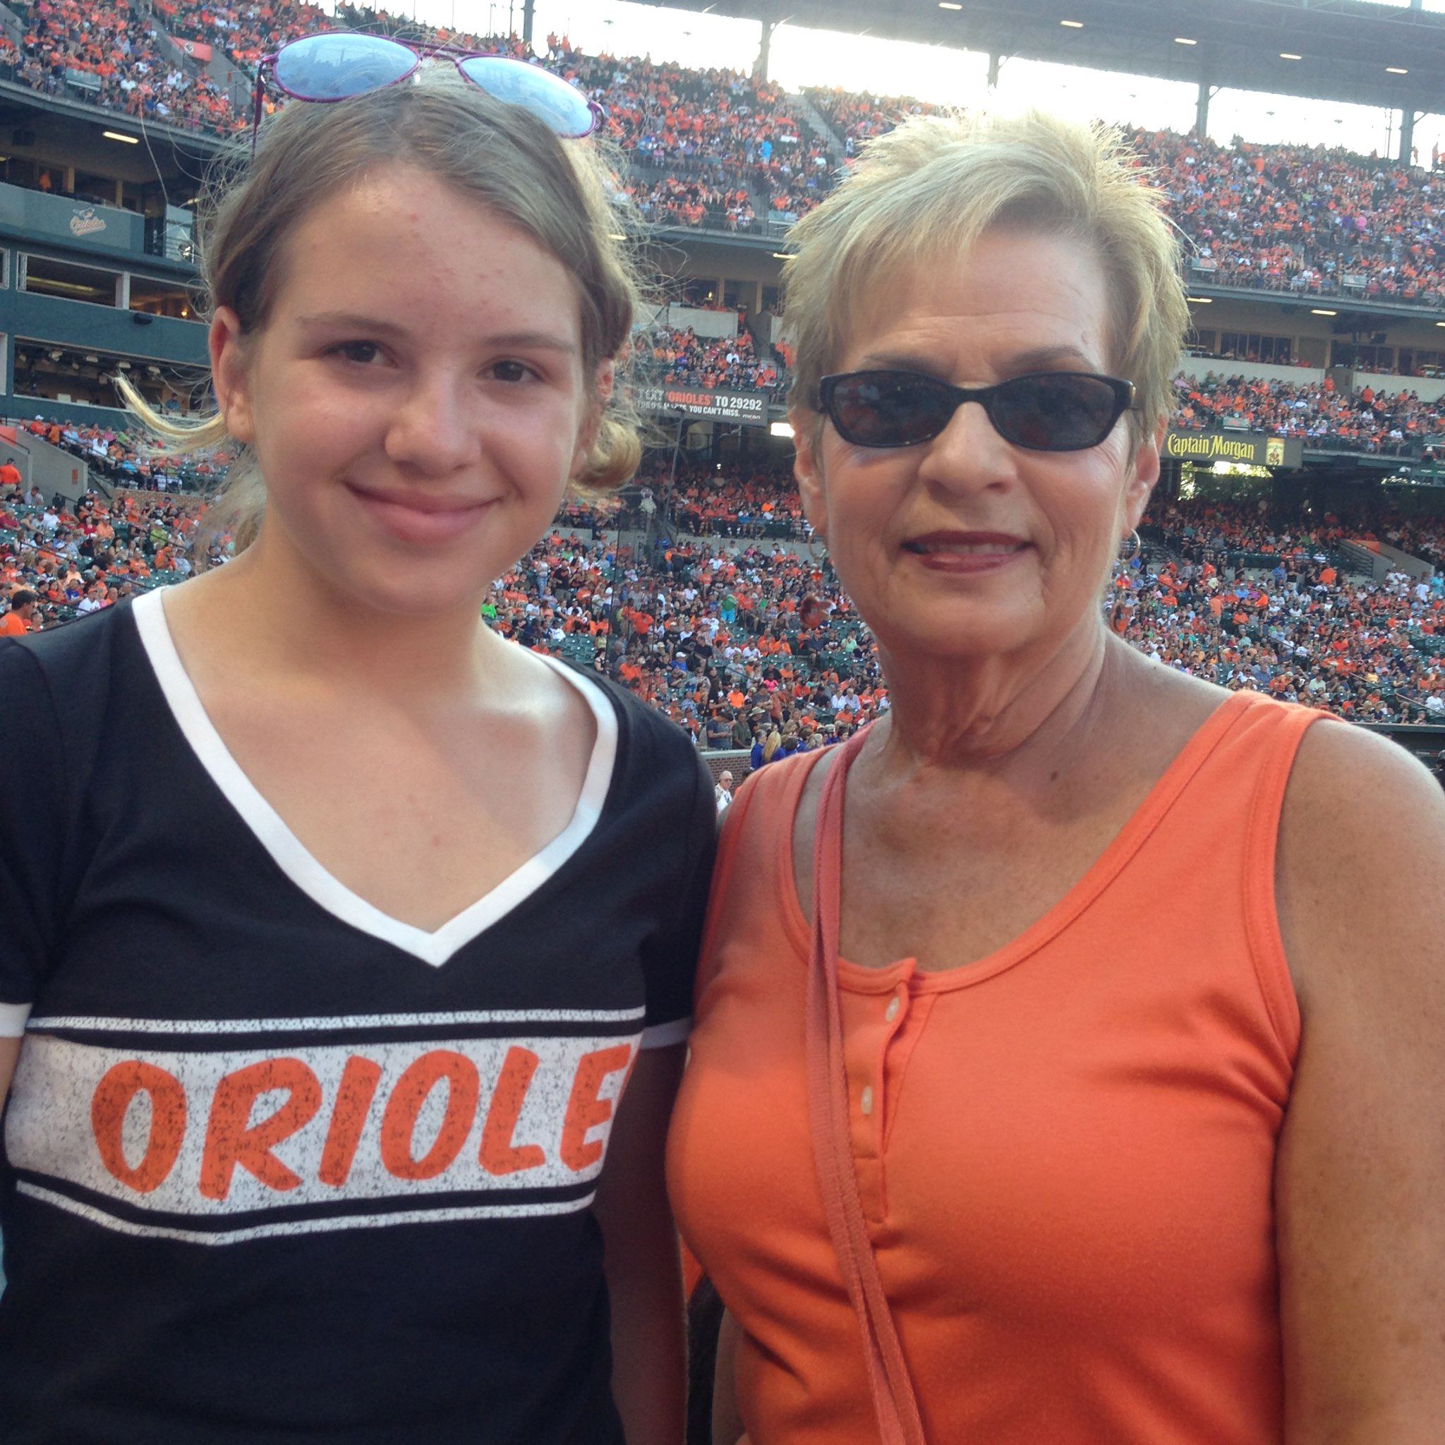

We are fundraising!
Visit our campaign at:
https://actheater.causevox.com/
Donations will help pay for the microphones and lights used in our show!

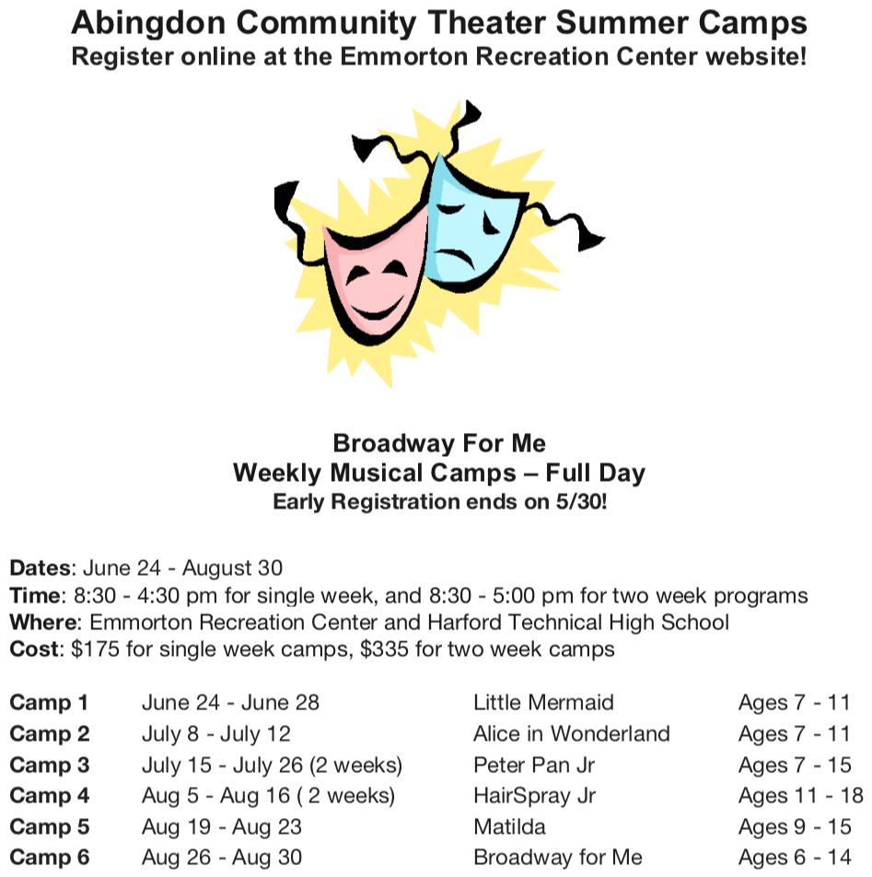

Registrations for our summer camp are now open!
For details please visit:
actheater.com

For questions please email us at:
act@actheater.com

SCENES & MUSICAL NUMBERS

PROLOGUE: CHERRY TREE LANE
Prologue Bert, Company

SCENE 1: CHERRY TREE LANE, PARLOR
Cherry Tree Lane (Part 1) George, Mrs. Brill, Robertson Ay
The Perfect Nanny Jane, Michael
Cherry Tree Lane (Part 2) George, Mrs. Brill,
Robertson Ay, Winifred

SCENE 2: CHERRY TREE LANE, NURSERY
Practically Perfect Mary Poppins, Jane, Michael

SCENE 3: A PARK
Practically Perfect (Playoff) Bert
Jolly Holiday Bert, Park Strollers, Jane, Michael,
Neleus, Statues, Mary Poppins

SCENE 4: CHERRY TREE LANE, PARLOR
Winds Do Change Bert
A Spoonful of Sugar Mary Poppins, Jane, Michael,
Honeybees, Winifred, Mrs. Brill, Robertson Ay
Spoonful (Playoff) Winifred

SCENE 5: INSIDE THE BANK
Precision and Order (Part 1) Clerks
Precision and Order (Part 2) Clerks, John Northbrook
A Man Has Dreams George

SCENE 6: THE CATHEDRAL STEPS
Feed the Birds Bird Woman, Mary Poppins,
Jane, Michael, Ensemble

SCENE 7: MRS. CORRY’S SHOP
Supercalifragilisticexpialidocious Mary Poppins, Mrs. Corry,
Bert, Jane, Michael, Customers

SCENE 8: CHERRY TREE LANE, PARLOR
Twists and Turns Bert

SCENE 9: CHERRY TREE LANE, NURSERY
Playing the Game Mary Poppins
SCENE 10: THE ROOFTOP
Chim Chim Cher-ee Mary Poppins, Bert, Ensemble

SCENE 11: CHERRY TREE LANE, PARLOR
Cherry Tree Lane (Reprise) Winifred, Jane, Michael,
Mrs. Brill, Robertson Ay, George
Brimstone and Treacle (Part 1) Miss Andrew

SCENE 12: A PARK
Let’s Go Fly a Kite Bert, Kite Flyers, Jane, Michael

SCENE 13: CHERRY TREE LANE, PARLOR
Brimstone and Treacle (Part 2) Miss Andrew, Mary Poppins
Practically Perfect (Reprise) Mary Poppins, Jane, Michael

SCENE 14: THE ROOFTOP
Step in Time Sweeps, Bert, Mary Poppins, Jane, Michael
Step in Time (Playoff) Bert, Sweeps

SCENE 15: CHERRY TREE LANE, PARLOR
Step in Time (Playoff) (cont’d) Bert, Sweeps
A Spoonful of Sugar (Reprise) Bert

SCENE 16: CHERRY TREE LANE, NURSERY
Anything Can Happen (Part 1) Mary Poppins, Jane,
Michael, Winifred

SCENE 17: INSIDE THE BANK
Give Us the Word George
Anything Can Happen (Part 2) Winifred, Mary Poppins,
Michael, Jane, George

SCENE 18: CHERRY TREE LANE, NURSERY
Goodbye Then, Mary Mary Poppins

SCENE 19: CHERRY TREE LANE, PARLOR
Anything Can Happen (Finale) George, Winifred, Company
Bows Company

