Director Marilda Miller
Music Director Katie Procell
Choreographer Marilda Miller, Lily Ellefson
Set Design Marilda Miller, Allison Berger,
Hayley Neal, Sophia Engel, Henry Weber, Lindsay Serio
Costume Design Marilda Miller, Betty Rogers
Lighting Design Brad Poulsen, Josh Oltanewski
Pascal Conroy, Lily Ellefson
Stage Manager Bryanna Ostendorf, Hayley Neal
Producer Michael Miller

Thank you to all the parents
for their tremendous support during the camp.
Thank you to Harford Technical High School
for supporting our kids.
Thank you to ERC management
for always supporting us.

Peter Pan JR. is presented through special arrangement with
and all authorized materials are supplied by
Music Theatre International, New York, NY
(212) 541-4684 mtishows.com
Abingdon Community Theater’s
PRODUCTION OF

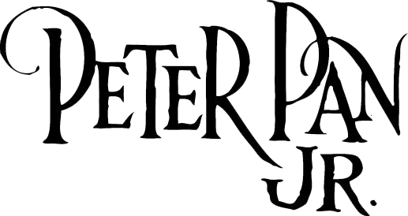

A Musical Based on the Play by
Sir J.M. Barri

Lyrics by Music by
Carolyn Leigh Morris (Moose) Charlap

Additional Lyrics by Additional Music by
Betty Comden and Adolph Green Jule Styne

Originally Directed, Choreographed and Adapted by
Jerome Robbins

In 1929 Sir J.M. Barrie bequeathed Peter Pan to Great Ormond Street Hospital For Children in London, which has benefited thousands of children since then. The producers are proud and happy that everyone who has bought a ticket for today’s performance of Peter Pan JR. is helping towards making the hospital the incredible center of hope it is today.
MUSICAL NUMBERS

Neverland Company
Prologue Wendy, John, Michael, Nana, Liza
Tender Shepherd Mrs. Darling, Wendy, John, Michael
I’m Flying Peter, Wendy, John, Michael
Pirate March Pirates, Lost Boys
Hook’s Tango Captain Hook, Pirates
Brave Girl Dance Tiger Lily, Brave Girls
Wendy Peter, Lost Boys
Hook’s Tarantella Captain Hook, Pirates
I Won’t Grow Up Peter, John, Michael, Lost Boys
Ugh-A-Wug Peter, Tiger Lily, Lost Boys,
Brave Girls, Darling Children
Distant Melody Peter, Wendy, Darling Children, Lost Boys
Hook’s Waltz Captain Hook, Pirates
I Gotta Crow Peter, Tiger Lily, Lost Boys,
Darling Children, Brave Girls
Nursery Music Nana, Mrs. Darling, Darling Children
Finale Ultimo Company

To register for Hairspray Jr Camp, Matilda Camp, and Broadway For Me Camp please go to actheater.com!

CAST

Peter Pan Jonah Wade
Wendy Allison Berger
Tinker Bell Raegan Decker
John Collin Jeffers
Liza Mary Grace Seibert
Michael Jackson Vaughan
Nana Courtney Conwell
Mr. Darling Henry Hoffman
Mrs. Darling Magen Cornacchione
Nibs Delaney Schatzer
Slightly Sophia Engel
Curley Lindsay Serio
Twin #1 Adrianna Medley
Twin #2 Kennedy Finlay
Tootles Angela Yeung
Captain Hook Henry Weber
Smee Gavin Reiley
Noodler Riley Clemmer
Jukes Alaina Bell
Dukes Emily Engel
Starkey Liam Stohm
Cecco Alaina Bell
Tiger Lily Lillian Jones
Brave Girl #1 Alaina Bell
Brave Girl #2 Andrea Serio
Lost Boys Sophia Engel, Lindsay Serio, Cecily Schatzer,
Charlotte Strohm, Adrianna Medley, Delaney Schatzer,
Mary Grace, Kennedy Finlay, Adriana Medley
Brave Girls Cortney Conwell, Lucia Seibert,
Magen Cornacchio, Adelle Campbell
Pirates Cooper Hoagland, Riley Clemmer,
Emily Serio, Liam Stohm, Alaina Bell

